
ICT PROJECT DOCUMENTATION

HEALTH SERVICE EXECUTIVE

ICT

National Integrated Services Framework Project

Project Plan for Information Architecture
Mini Project

Author Peter Connolly
Sept 2013

Version 1.0

Table of Contents
1 Document Control 3
1.1 Document Location 3
1.2 Version History 3
1.3 Approvals 4
1.4 Distribution 4
2 Purpose of this document 4
3 Description 4
4 Project Deliverables 5
5 Project Schedule 9
6 Project Quality Plan 10
7 Communication Plan 12
8 Financial Plan 14
9 Resourcing Plan 14
10 Detailed Plan for the Next Stage 14
Appendices 16
10.1 Appendix A 16

- Document Control

Document Location

The source of the document will be found on the ICT Shared Domain under the ISF Programme Folder.

Version History
Version date | Changes | Author | Reviewer
20/09/2013 | 0 | P. Connolly | G.Hurl  F. Thompson  R. Schippers  G. Feriks

Approvals
This document requires the following approvals.

Approval Authority | Name | Version Date | Approval Date
 | G.Hurl  F. Thompson | 20/09/2013  20/09/2013

Distribution
This document has been distributed to:

Name | Title | Date of Issue | Version
G.Hurl  F. Thompson  R. Schippers  G. Feriks | Sponsor 1  Sponsor 2  Contractor / Project Manager 1  Contractor / Project Manager 1 | 20/09/2013  20/09/2013  20/09/2013  20/09/2013 | V1.0  V1.0  V1.0  V1.0

Purpose of this document

The purpose of the Project Plan is to provide a statement of how and when a project’s objectives are to be achieved, by showing the major products, activities and resources required on the project.

Once approved by the Project Board, all changes to the project plan must be effected via the approved change control process.

Description

The overarching purpose of the work components in this mini-tender are to provide a ‘standards based blueprint’ for the Data Model and broader Healthcare Information Architecture for the future support our users and our technology base.

The immediate objective is, using a standards basis to determine both what, and how, data should be shared across multiple ICT applications within the HSE and where appropriate its partner agencies. This objective includes how the data is to be shared and managed at a systems level.

It does not seek to determine how data will be used within the business domain, but rather to provide a core referential model that is standards conformant and facilitates semantic and syntactical computability across our platforms and technologies.

The plan has 4 distinct groups of deliverables and engagement is undertaken using both workshops and 1:1 interviews.

Project Deliverables

The project deliverables are listed in the attached appendix and the work breakdown structure and order of their delivery is outlined below.

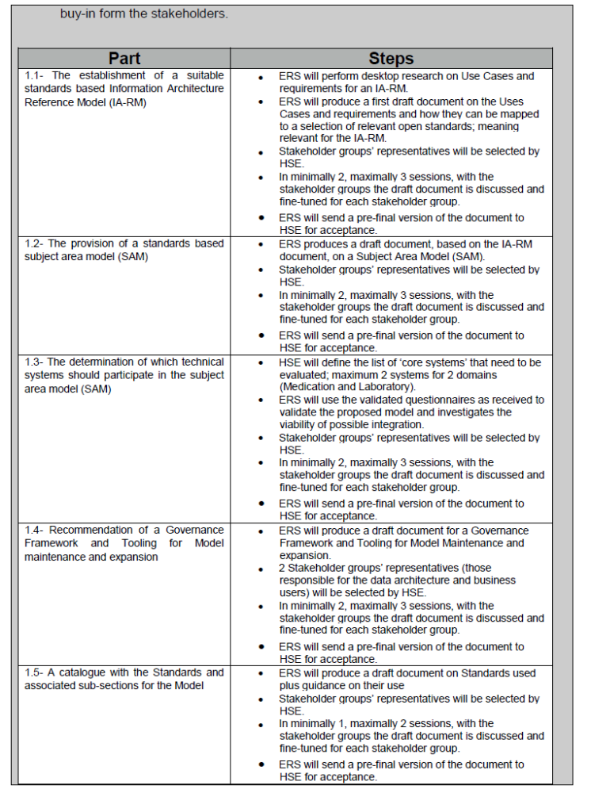

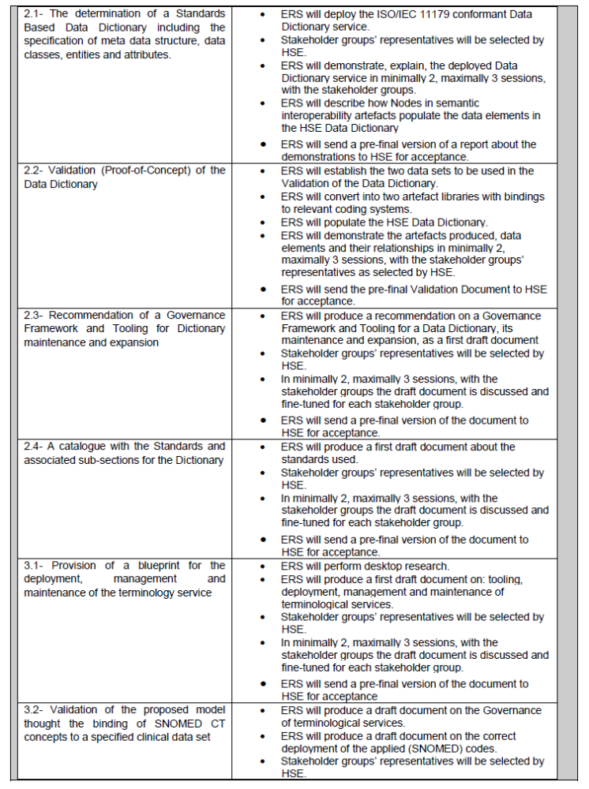

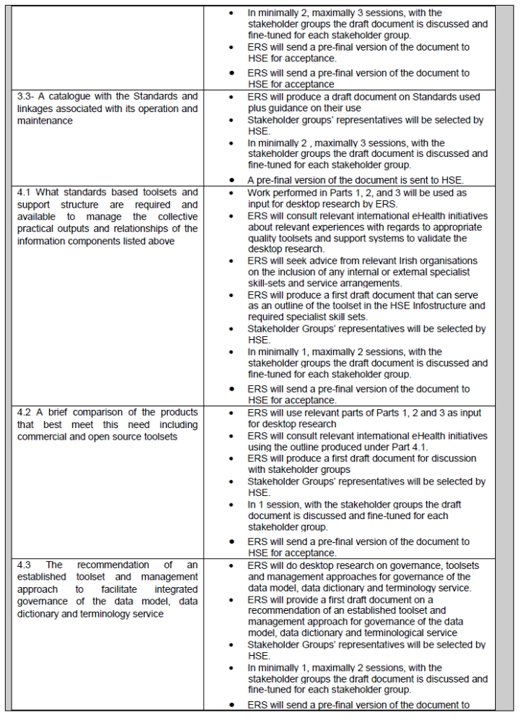

- Project Schedule

This is a short and focussed piece of work spanning four months duration, and the key timelines for project deliverables are shown below. There are a number of interdependencies, primarily between the data dictionary and terminology assurance. In this regard

Part-1 Determination of the Information Model | Due Date
- The establishment of a suitable standards based Information Architecture Reference Model (IA-RM) | Fri 6/12/2013
- The provision of a standards based subject area model (SAM) | Fri 6/12/2013
- The determination of which technical systems should participate in the subject area model (SAM) | Fri 6/12/2013
- Recommendation of a Governance Framework and Tooling for Model maintenance and expansion | Fri 6/12/2013
- A catalogue with the Standards and associated sub-sections for the Model | Fri 6/12/2013
Part-2 Data Dictionary

- The determination of a Standards Based Data Dictionary including the specification of meta data structure, data classes, entities and attributes | Fri 13/12/2013
- Validation (Proof-of-Concept) of the Data Dictionary | Fri 13/12/2013
- Recommendation of a Governance Framework and Tooling for Dictionary maintenance and expansion | Fri 13/12/2013
- A catalogue with the Standards and associated sub-sections for the Dictionary | Fri 13/12/2013
Part-3 Terminology Assurance

- Provision of a blueprint for the deployment, management and maintenance of the terminology service | Fri 31/01/2014
- Validation of the proposed model thought the binding of SNOMED CT concepts to a specified clinical data set | Fri 31/01/2014
- A catalogue with the Standards and linkages associated with its operation and maintenance | Fri 31/01/2014
Part-4 Support Processes & Services

- What standards based toolsets are required to manage the collective practical outputs and relationships of the information components listed above | Fri 31/01/2014
- A brief comparison of the commercial and open source products that best meet this need | Fri 31/01/2014
- The recommendation of an established toolset and management approach to facilitate integrated governance of the data model, data dictionary and terminology service. | Fri 31/01/2014

Project Quality Plan

Twice weekly conference calls or on-site meetings will be held with the project manager to advise on progress and review any quality issues. Key qua;ity dependencies for review include stakeholder engagement, data dictionary validation and terminology assurance.

Inputs from the listed key stakeholder groups must be included as part of the recommendations, and a draft copy of material at each end of stage engagement must be circulated to all participant stakeholders for final comment prior to sign off.

In the event of a recommendation and material being submitted witout stakeholder engagement a rational for same must be included.

Final QA will be provided by the project manager, project board and a number of ICT and eHealth and external Standards Professionals from both the HISC and Academia.

QA is based upon the timely completion of the deliverables, followed by cross matching for completeness and quality. Each of the deliverables will be circulated to the review group who will then convene to discuss and approve or seek amendment as required.

The baseline of required deliverables is listed in Section 3 of this document, along with the prototype deliverables clarified by ERS in July 2013 will also be provided to the HSE.

Quality checks will be carried out at each stage by the review team comprising of:

Peter Connolly | HSE | All
Fran Thompson | HSE | All
Seamus Butler | HSE | Systems & Standards
Dr Damon Berry | HISC | Standards
Dr Pam Henry | HISC | Standards
Prof Gaye Steevens | HISC | Standards
Dr Kevin O’ Carroll | HIQA | Standards & Regulation
Dr Gary Courtney | Clinical Lead | Clinical
Bernie Hyland | HSE | Standards & Data Collections
Chrissie Keane | NSAI | Standards
Miriam Wylie | ESRI | Standards & Data Collections
Leo Kerrins | HSE Reform Group | Standards & Business
Nicholas Oughtibridge | NHS | Standards
Doug Fridsma | ONC | Standards & Connectivity
Lisa Halstrom | epSOS | Data Assurance

The agreed datasets for the prototype will be agreed by the 4th of October. It presently assumed to be an EPSOS conformant Discharge Dataset, embracing the National Diabetes Dataset and one other dataset, and SNOMED CT will be used for the terminology bindings to the dataset. The prototype will be reviewed and Qulity Assured by Clinical Representatives of the National diabetes team.

The outputs of the prototype will be exportable and presentable for demonstation purposes and also for system adoption if required.

- Communication Plan

Stakeholder engagement is an important part of this work programme, and they are spread acoss the ICT, Business, Clinical and inter-agency domains. They will be invited to attend a number of workshops or 1:1 consultation sessions, and their invitation to attend will be made primarily via email by the ISF project manager.

Although many are familiar with the ISF Project, and the importance of a Standards Based Architecture for our technologies and Information Architecture, the relevance of this will be articulated to their domain of responsibility along with objective of the workshop.

The consultation process has made provision for 20 consultation sessions of 2.5 hours duration, that is 60 hours of stakeholder engagement.

ERS will be provided with office space for the purposes of 1:1 meetings and have access to a number of meeting rooms for the purposes of workshop engagement.

The following (minimum) list of stakeholder groups must be consulted at a face-to-face level as part of the programme of work.

The Stakeholder list stretches across four key groups, and based on its breath it is preferable that four workshops are offered, with non-attendees being offered the opportunity of 1:1 engagement of telephone consultation. This also makes provision for any final review contact with stakeholders if deemed appropriate.

No vendor engagement is planned, but if required it can be accommodated.

Workshop-1 (3 Hours)
(i) ICT(Standards & Technology):
The ICT Senior Management Team
The ICT PMO
The ICT Planning Team
ICT Corporate Information Facility Team
Tertiary Hospital ICT Management

[Invitees = 50 Persons]

Workshop-2 (3 Hours)
(ii) Business:
Corporate Planning & Corporate Performance (x2 teams)
Health Intelligence Team
Public Health (x2 teams)
Special Delivery Unit & CMIO
HSE Procurement
Patient Level Costing / Miriam Wiley / Brian O’ Donovan / John McLoughlin
Anne McMenamin / Performance Improvement
Reform Group

[Invitees = 50 Persons]

Workshop-3 (3 Hours)
Other Agencies (Standards Focus)
Health Information & Quality Authority
National Standards Authority of Ireland / HISC
Department of Health (ICT & CMO)
ICGP (Brian O’ Mahony)
Industry – Oracle
Orion
Harris
iSoft
Cerner
Intersystems
IBM
Intel

[Invitees = 50 Persons]

Workshop-4: (3 Hours)
Clinical
RCSI- FL
Gary Courtney
Aine Carroll
Clinical: Clinical Programme Director
Clinical Leads
Academia

[Invitees = 50 Persons]

- Financial Plan

Payment Schedule as agreed upon completion of each stage.

Resourcing Plan

Staffing resources to be provided by the contractor (ERS). An office will made available at the HSE ICT Centre in Dr Steevens’ hospital, Dublin. ICT services will also be provided along with room bookings for workshops on requested dates.

Detailed Plan for the Next Stage

Specific dates for engagements to be provided by/ determined with ERS before end of September following final sign-off and award of contract.

Appendices

Appendix I

National Integrated Services Framework

Mini –Tender 1: Information Architecture

( Work Components 1 – 4)

Introduction

Standardisation is a fundamental requirement for truly shareable Electronic Health Records (EHRs) and the harmonious delivery of Universal Health Insurance. Equally it provides the basis for quality assured real time data collections from autonomous yet aligned institutions.

With an expanding national healthcare asset profile of around €1bn in ICT technologies including 1,700 applications, a standards based roadmap offers both an essential tool and an internationally established method of best practice for ensuring system alignment and strategic management of the HSE’s ICT portfolio.

In recognition of this need, and based on international best practice the HSE’s ICT National Integrated Services Framework (ISF) project has been established to develop a practical standards based framework for applications, information, communications and technical architectures. This standards based framework will define the environment in which we design, develop and acquire systems in the future.

This is a CMOD (Dept. of Finance) approved project, and when complete the framework will ensure that the manner in which we deliver ICT solutions is aligned with the overall national strategy and business objectives. Implemented correctly, the framework will ensure that the required levels of integration between systems are achievable.

Upon commencement of the project a review was undertaken of global best practice including solution demonstrations and site visits. It was quickly recognised that HSE ICT needs to ensure the adoption of a holistic and yet pragmatic step-wise approach to the establishment of the framework.

This approach requires the early establishment of a standards based reference model incorporating a shared Data Dictionary and a suitable terminology such as SNOMED CT. The purpose of this mini-tender is to determine at a conceptual and partly functional level the structural components and relationships required within the model.

The data model resulting from this mini-tender process will be used to provide a referential basis for the alignment our ICT systems, specifically for improved semantic and syntactical interoperability and to lay the foundation for a standards based Information Architecture.

The deliverables outlined herein also have a number of practical elements to ensure future viability and to facilitate planning for broader implementation and scalability.

Aside from clear cut technical benefits, the deliverables will be shared with all stakeholders as it will facilitate enhanced data collections, improved data quality and act as a catalyst for business model improvements, as per LOT-3 of the original tender.

Mini-Tender Work Programme Objectives
The overarching purpose of the work components in this mini-tender are to provide a ‘standards based blueprint’ for the Data Model for the future support our users and technology base.

The immediate objective is to determine both what, and how, data should be shared across multiple applications within the HSE and where appropriate its partner agencies. The objective is also to determine how the data is to be shared and managed at a systems level.

It does not seek to determine how data will be used within the business domain, but rather to provide a core referential model that is standards conformant and facilitates semantic and syntactical computability across our platforms and technologies.

The outputs of this endeavour (data model) will be made available to the business user community for evaluation and extrapolation to their individual requirements. As is the international experience, the model will undoubtedly require future modifications and extensions over time to meet such needs.

The model must also be quality assured to validate its capability and suitability within the current technology and user setting. This will require the standardisation and structuring of one or more sample datasets and their practical validation (Proof-of-Concept) within the proposed model.

A central component of the model will be the Data Dictionary. It will be necessary to determine the structure and content of the dictionary including where and how the properties, associations, and constraints of content should be defined.

A key principle underpinning our approach is the need to leverage the potential afforded in existing (core) technologies and to ensure they are part of the model. Some of these already have integrated bespoke dictionaries and datasets.

With regard to implementation and advancement of the model consideration should be given to the fact that the desired approach is one of gradual incremental migration toward the end goal of a truly interoperable healthcare data model and information architecture.

Further work will be required to refine the model and bend it to immediate stakeholder needs. This in turn will lead to an increased level of practical application of the model.

A governance group is currently under consideration for the broader use of the emergent data model. Its establishment is unlikely to have a direct impact on this phase of work. However, the outputs of this work package will be considered by the new governance group with regard to the adoption and use of the model by business stakeholders. Accordingly, whilst the deliverables will be technical in nature the over riding narrative or executive summary from this work should be interpretable by a business user audience.

Outline of Requirements

The order of approach to a ‘Standards Based Information Architecture’ for the HSE’s ICT Systems and Irish healthcare infostructure in general requires a step-wise approach, whereby core foundational elements can be established and validated prior to broad adoption. The project board has prioritised the following four areas;

- Determination of the (Standards Based) Information Model
- Specification for the (Standards Based) Data Dictionary
- Terminology Assurance
- Support Processes & Services

If successful these deliverables should be directly implementable and they will also be used to inform the workstreams contained within LOT:2 and LOT:3. The detailed specification of these requirements follows herewith.

PART 1 :

INFORMATION MODEL REQUIREMENTS

Part-1 Determination of the Information Architecture Reference Model

- The establishment of a suitable standards based Information Architecture Reference Model (IA-RM)
- The provision of a standards based subject area model (SAM)
- The determination of which technical systems should participate in the subject area model (SAM)
- Recommendation of a Governance Framework and Tooling for Model maintenance and expansion
- A catalogue with the Standards and associated sub-sections for the Model

- The establishment of a suitable standards based Information Architecture Reference Model (IA-RM)

Currently no ‘ICT Standards’ based reference model exists for the HSE’s information architecture. From the outset, the project board has considered this as being an essential structural component and have also deemed it a critical starting point.

The requirement is for the specification of a ‘standards based’, overarching Information Architecture model which takes consideration of existing and planned business activity. It will be used a referential tool to define, explain and provide oversight for data requirements and structures with key stakeholders before final endorsement.

The model should give consideration to the ‘Standards Based’ foundational requirements for semantic and syntactical interoperability of Health ICT Systems across a TRUST based structure. The model should define the necessary foundational components required for assured Data Collections and a future ‘standards assured’ National EHR. .

Within an international context it is noted that partial examples of this model exist within Healthcare ICT, for example high level expressions of the NHS Logical Record Architecture, as well as the Canadian Infoway and Singapore Information Architecture Models. Our requirement in this section is simply for a conceptual model which may be easily articulated by suppressing heavy technical detail and ideally only contain clearly defined ‘standards based’ elements related to a high level holistic overview of the architecture.

It should also be noted that other partner agencies have also agreed to provide comments and guidance to the successful parties. These include NSAI, HIQA and Academia.

- The provision of a standards based subject area model (SAM)

The determination and provision of a ‘standards based’ subject area data model which draws on the IA-RM model above and will be used to inform major information system structuring decisions, and to define the structure and integration of future ICT systems at the data level.

- The determination of which technical systems should participate in the subject area model (SAM)

Consideration must be given to the fact that a number of core systems must be able to conform to the SAM without unviable demands being placed on these systems and their interfaces. To validate the proposed model it will be necessary to identify these systems and verify the viability of their integration within the overall model.

- Recommendation of a Governance Framework and Tooling for Model maintenance and expansion

It is necessary to establish an appropriate toolset and convention for the data model which will provide for quality assurance and ease of use. The Governance and Maintenance arrangements must provide capability for two audiences, firstly for those responsible for the data architecture and secondly the business users for whom the data model is being developed.

- A catalogue with the Standards and associated sub-sections for the Model

The provision of a list of the data standards applicable in part or entirety to the model, along with a brief explanatory script or blueprint to provide appropriate guidance to the user in a readily understood manner. Where possible, any relationships with other standards already recommended in parallel workstreams should also be noted.

PART 2 :

DATA DICTIONARY REQUIREMENTS

Part-2 Data Dictionary

- The determination of a Standards Based Data Dictionary including the specification of meta data structure, data classes, entities and attributes
- Validation (Proof-of-Concept) of the Data Dictionary
- Recommendation of a Governance Framework and Tooling for Dictionary maintenance and expansion
- A catalogue with the Standards and associated sub-sections for the Dictionary

  - The determination of a Standards Based Data Dictionary including the specification of meta data structure, data classes, entities and attributes

Specification of a Standards Based structure for the HSE’s Master Data Dictionary, including provisions for integrity of meaning, relationships to other data, origin, usage, and format. Content for the data dictionary will include both clinical and related data items. When commissioned the data dictionary will have associations with data sets and other reference sources including terminologies and classifications. The data dictionary may be based upon a commercial, open source, or alternative national platform. However, it must be architected upon a ‘standards based’ structure.

  - Validation (Proof-of-Concept) of the Data Dictionary

Demonstration of the standards based structure and functionality of the Data Dictionary. A number of clinical data sets can be made available for this purpose and if successful the prototype may be formalised and applied for full stakeholder usage. The proposed dataset(s) will contain no more than one hundred items.

  - Recommendation of a Governance Framework and Tooling for Dictionary maintenance and expansion

This requires the determination of suitable arrangements for assuring the integrity and quality of the dictionary. When commissioned the data dictionary will have associations with data sets (both clinical and business) along with other reference sources including terminologies and classifications. Appropriate tooling and a proven standards based governance model needs to be identified designed, and presented in a manner that will address this requirement.

- A catalogue with the Standards and associated sub-sections for the Dictionary

The provision of a list of the data standards applicable in part or entirety to the data dictionary, along with a brief explanatory script or blueprint to provide appropriate guidance to the user in a readily understood manner. Where possible, any relationships with other standards already recommended in parallel workstreams should also be noted.

PART 3 :

TERMINOLOGY ASSURANCE REQUIREMENTS

Part-3 Terminology Assurance

The determination and validation (Proof-of-Concept) of a terminology (SNOMED CT) for the IA-RM Model through;

- Provision of a blueprint for the deployment, management and maintenance of the terminology service
- Validation of the proposed model thought the binding of SNOMED CT concepts to a specified clinical data set
- A catalogue with the Standards and linkages associated with its operation and maintenance

  - Provision of a blueprint for the deployment, management and maintenance of the terminology service

The objective of this deliverable is to determine the necessary foundational components and structure for the deployment, management and maintenance of the terminology service. Although the core focus of this requirement relates to SNOMED CT, the design should be able to accommodate additional terminologies such as LOINC, ICD-10 etc.

  - Validation of the proposed model thought the binding of SNOMED CT concepts to a specified clinical data set

The confirmation of suitability (or otherwise) of SNOMED CT as an adoptable terminology for use within our core systems. The process requires the binding of a number of clinical data set elements (100 elements approx) to the SNOMED CT terminology. The process and output of this effort will be reviewed for scalability and deployment within our systems and stakeholder settings. It will also be reviewed by HIQA and NSAI for quality control and Governance Assurance including guideline development. Ideally, the terminology validation will be based upon the dataset associated with validation of the Data Dictionary in Part-2 above.

  - A catalogue with the Standards and linkages associated with its operation and maintenance

The provision of a list of the data standards applicable in part or entirety to the terminology service, along with a brief explanatory script or blueprint to provide appropriate guidance to the user in a readily understood manner. Where possible, any relationships with other standards already recommended in parallel workstreams should also be noted.

PART 4 :

SUPPORT PROCESSES & SERVICES

Part-4 Support Processes & Services

To provide insight and recommendation as follows;

1. What standards based toolsets are required to manage the collective practical outputs and relationships of
the information components listed above
2. A brief comparison of the commercial and open source products that best meet this need
3. The recommendation of an established toolset and management approach to facilitate integrated
governance of the data model, data dictionary and terminology service.

Part-4 Support Processes & Services

  - What standards based toolsets and support structure are required and available to manage the collective practical outputs and relationships of the information components listed above

This requires a brief outline of the appropriate quality toolsets and support system by which the current and future use of the IA-RM, DD, and Terminology Services can be effectively directed and managed in a controlled and integrated manner. Consideration should include any internal or external specialist skillsets and service arrangements.

  - A brief comparison of the products that best meet this need including commercial and open source toolsets

HSE ICT runs a mixed IT environment, and wishes to make a decision based on informed choice as to what toolset(s) are best for these emerging system needs. The brief comparison should include proven and well established products with reasonable functionality. The brief comparison should include commercial and open source products, and if deemed appropriate any in-house bespoke toolsets available from 3rd parties or potential collaborative agencies.

  - The recommendation of an established toolset and management approach to facilitate integrated governance of the data model, data dictionary and terminology service

This recommendation should be based on proven product functionality and scalability whilst also taking cognisance of the current organisational (fiscal) constraints.

Points for Guidance

Context

Data standardisation and reference terminology are urgent business priorities for HSE ICT, our stakeholders and allied healthcare agencies. The work components outlined in this mini-tender are an abstraction of the broader requirements listed in LOT: 4 of the original qualifying tender. They will be used to inform and guide the HSE’s ICT journey towards a ‘standards based’ electronic health infostructure that enhances health care quality and efficiency for all patients.

The outputs will be used to assist core information stakeholders with their future data requirements, and to facilitate the alignment and integration of ICT systems for a robust and standardised infostructure.

The outputs from this piece of work will act as a catalyst for some of the work components that follow on especially within LOT: 3 (Business Architecture). It is important therefore, that the deliverables specified herein, shall be to a large degree interpretable by a non technical audience.

It can also be seen that the requirements specified for the Data Dictionary and Terminology Service have a practical nature. This is in order to validate their suitability for a full scale deployment, and if this proves successful these outputs are likely to be broadly and rapidly implemented in our core technologies to facilitate an enhanced level of functionality and business value.

Guiding Principles

This project began with a broad global review of the best practices and standards based ICT infrastructural deployments for healthcare delivery. Both formal and informal contributions were provided by a large number of leading edge practitioners including The NHS, Infoway Canada and the Netherlands. Their recommendations have led to a set of guiding principles which have helped shape our approach to this important task.

MOU

A memorandum of understanding (MoU) was established in 2011 between the NHS NpfIT and the HSE for the purposes of collaborating and sharing information, as well as to support future collective endeavours in the area of standards based healthcare information Architecture. As such the MOU has not been applied in any formal way but may be of interest to tendering parties who may wish to consider any potential it could offer in addrerssing the requirements outlined herein. However, it should be noted that any outputs under such an arrangement would be made available to the NHS and any relevant 3rd parties including existing HSE system suppliers.

Deliverable Material

The primary value derived from this piece of work is the ‘standards based’ Information Architecture Reference Model (IA-RM) and the validation of some of the key underpinning components. The awarded organisation(s) will be required to provided the deliverables in the following manner:

  - Electronic copies (Microsoft Office) of the Data Model requirements outlined above with related explanatory documentation
  - A working scalable model of the Data Dictionary as specified above including as appropriate hardware, software, and any related licensing along with related explanatory documentation
  - A working scalable artifact for terminology assurance as specified above including as appropriate hardware, software, and licensing along with related explanatory documentation
  - A presentation of these deliverables (powerpoint) to a broad stakeholder audience

It is important to note that the deliverables are of significant strategic importance as they will impact on the manner in which our ICT Infostructure empowers healthcare delivery. Their practical nature is simply a validation of their future role within the Infostructure Framework.

It is also important to note that this is not about technology procurement, and as such any material associated with the demonstration of the Data Dictionary and Terminology Assurance requirements should accordingly reflect the constrained and limited nature of these specifications.

Timelines

The priority is on ensuring that the deliverables are complete and of appropriate quality. Whilst tenderers may adopt a number of different approaches to the task it, a four to six month timeframe is envisaged for completion of the deliverables as outlined in the attached schedule.

Constraints

Tenders may apply for one or more of the three core deliverables; however each deliverable must be addressed in its entirety. Only agreed data set(s) may be used for the Data Dictionary and Terminology requirements.

Requirements

Tenderers are requested to submit an outline of their proposed approach with indicative stage timelines and associated costs.

APPENDIX – I

Synopsised Version of Related Workstreams

